I’m the first “man” on the moon!
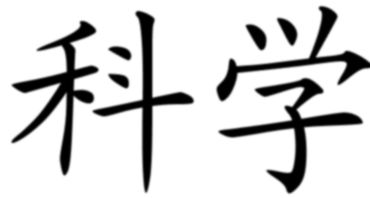
I blast off into space, my wheels a-turning.
I’m excited, I can’t wait to get my engines burning.
Mama, Papa, creators- I’m going higher than the clouds.
I hope that I can make all of you proud.

You always told me to shoot for the moon
And if not, land amongst the stars.
But I’m going to be the Neil Armstrong of my country soon.
A famous Chinese ambassador light-years afar.

Chang’E, I hope you welcome me with open arms.
I have returned home, my goddess, to do you no harm.
Just to explore the beauty of this white, milky earth,
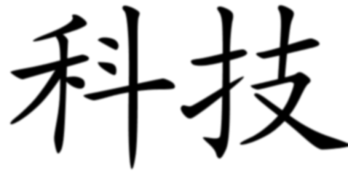
From which my people believe are the origins of our birth.

The American Armstrong, did he not leave his footprint here?
One small step for a man, a giant leap for mankind.
Allow me to do the same, then, and make it clear,
That the people of China are following right behind.

Lo and behold, we are no longer a poverty-stricken nation.
We have hopes and dreams and a blooming imagination.
Communism can’t stop me from taking great pride,
In my people’s rising stature and technological strides.

Geisha

This figure, bathed in the royalty of the sea
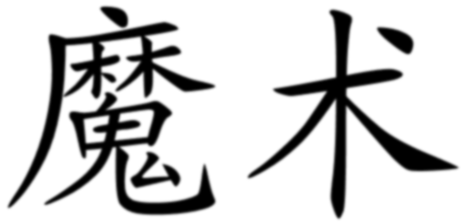
Blood-red rivers of her forefathers and mothers
The golden dew drops of sunlight
Threaded into her flowing robes.

Her duty is to her family
She is a mother, wife, a female figure
Her job is to entertain, to sing, to dance
And she offers her body to you
For pleasure and romance.

What you see of a geisha, that is not all that she is.
Sometimes imprisoned as a sex slave
And sometimes willingly allowing men to enter her
All business for the customers, the hungry clients.
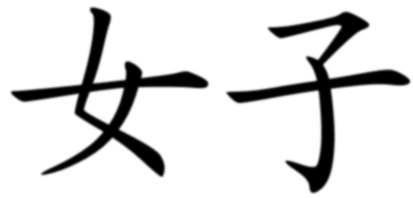
Artistic, skilled, entertaining.
She loves to sing, to dance, to create beautiful music.
Wild and outrageous, controlled and stylistic.
Actress, prostitute, artist, companion,
Wrong impressions from the Western world
the many faces of a geisha.

When she dances, she tells her own story
Hand gesture, she writes a love poem
Her long sleeves, she dabs her tears.

When she sings, her voice the melody of a goddess
The notes echoing the pain, the triumph, the love
Her chorus weaving tales of the Japanese culture.

When she speaks, her words are careful and formal.
Her charm and knowledge, she builds connections
At teahouses and social parties.

The war, the Second War of the World,
Where did all of the geisha sisters go?
Working in the factories, keeping alive,
The geisha life nonexistent.

Lo and behold, they soon emerged again
And this time, with such power and action
Her duty is not only to entertain
But to preserve a culture, one lost long ago.

She is no longer a slave, forced into acts
Her life now her own business
the right to do as she pleases
power to write her own stories.

And what is to stop me, for now I have the power
A geisha, an entertainer, a storyteller
I can weave my own fairy tale.
And call it a work of art.

I can be a samurai
Fighting alongside the men.
Or a farmer, like my fathers,
Toiling in the fields.

I can dream of a forbidden love and adventure!
My footsteps a dance of anguish and victory!
My songs a celebration of life and history!
My language a sign of my wisdom and genuity!

And that is why I am a geisha.
To embrace my culture
To transcend my role as a woman
To cherish the beauty and magic of existence.

A profession, the stereotypes say?
Prostitution, wasteful, women gone wild?
A way of life, I say.
Telling stories and mastering the fine arts of life.

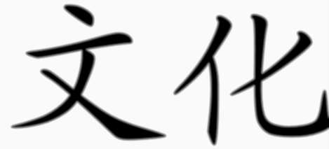
The “American” Dream

Society, wishing and wanting for success
A new car, a big house, a perfect family
And money, money, enough to go around
Dreamers, we are all looking to find happiness.

Me, a college student, diligent and smart
I travel to another world ready to embrace freedom
And find myself in the grasps of adulthood.

“How am I to pay of these debts, get good grades?” I sigh
Discouraged:
I continue with my American educations, our futures uncertain.

My father, hardworking and strong
He comes to America with hopes for prosperity
And is met with financial woes and failing business.

“What did I do wrong?” he asks
Dissatisfied:
He does not call himself an American.

My mother, headstrong and devoted
She arrives as the caretaker and bread-bearer for the family
And now, unemployed, a victim of racism and economic strife.
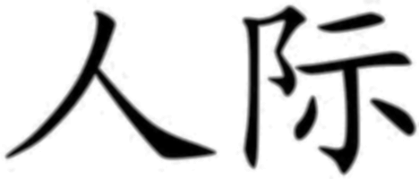
“I don’t know what will happen,” she worries
Disillusioned:
She clings onto broken American dreams.

My brother, young and innocent
He goes home with desires for mansions, wealth, and video games
And faces the reality of life with a distant, silent family.

“Why can’t we ever afford anything or have fun?” he wonders
Disappointed:
He yearns for his magical American dreams.

My family, you, me, we all keep fighting
Yes, we the people of the United States
The discouraged, the disillusioned, dissatisfied, disappointed
Immigrants, natives, foreigners, settlers
Black, white, yellow, brown, tan.

Yet, we are still humans, dreamers, workers
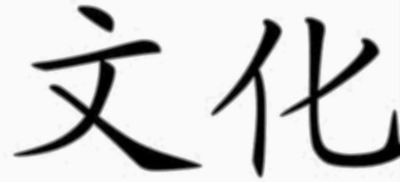
United by our struggles, hopes, desires
Fueled by our failures, this negativity
To one day make our American Dreams come true.

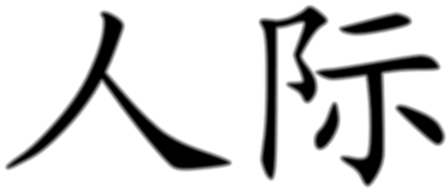
Artist’s Statement

My work is a reflection not only upon the three core themes of my Asian American Studies class: technology, science, and magic, but a celebration of my Asian (in particular, Chinese) heritage and culture. Within each of my poems is my interpretation of the Asian culture and the beauty that lies within the three core aspects. Each topic pertains to an idea or invention that relates to the Asian culture. Behind each poem is a Chinese symbol corresponding to the theme I believe fits well for the poem. For example, in my poem I’m the First “Man” on the Moon, I write the story about a real-life Chinese space probe named “Jade Rabbit” who was designed to explore the Moon. The “Jade Rabbit” has deeper roots into Chinese mythology, as discussed in the poem. I thought this fit well with the themes of science and technology. In my poem Geisha, I take a slightly feminist approach and explore the life of a Japanese geisha, her work, and her struggles with identity and her rights as a woman. I thought this poem fit well with the female and magic aspect of Asian culture. Lastly, in my poem The “American” Dream, I hit closer to home and discuss my personal experiences, as well as my family’s, of living in America and embracing the American Dream. My parents are immigrants to this country, and I believe their struggles and triumphs in America are prime examples of what many other immigrants to America are going through. I wanted to show that the American Dream doesn’t always come true for anybody, and through this negativity, individuals can either give up on their dreams or continue pursuing them. The themes of human and culture fit well with this poem because despite my Asian heritage, or any immigrant’s heritage for that matter, we are all American citizens and belong to this country we call home. By writing these poems, I hope to have instilled a greater appreciation for Asian and American culture. Although the two clash in many ways, it is important to recognize that they are equally important and play a major role in shaping our lives.

